TECH-CAREER Creating a pathway for Ethiopian Israelis into high-tech | 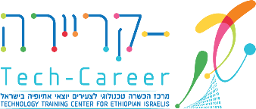

THE CHALLENGE  High-tech employs 12-16% of Israel's workforce and pays more than twice the national average wage, yet fewer than 5% of working-age Ethiopian Israelis work in the sector. Just 18% pursue STEM degrees versus 33% nationally, and average wages in the community run 43.6% below the Jewish population average. With 36% of Ethiopian Israelis between the ages of 20 and 39, addressing the pipeline gap into high-tech is urgent: closing it requires exactly the kind of structured, sustained intervention that Tech-Career provides.  OUR RESULTS  97% Program Completion Rate 97% Certification Rate 85% Placement Rate  For over two decades, Tech-Career has been turning potential into careers: training more than 1,500 Ethiopian Israeli young adults and placing them in high-tech roles, most the first in their families.  “Tech-Career didn’t just change my career; it changed my family’s future. I’m the first in my family to work in high-tech, and now my younger siblings believe they can do it too.”  — Tech-Career Graduate  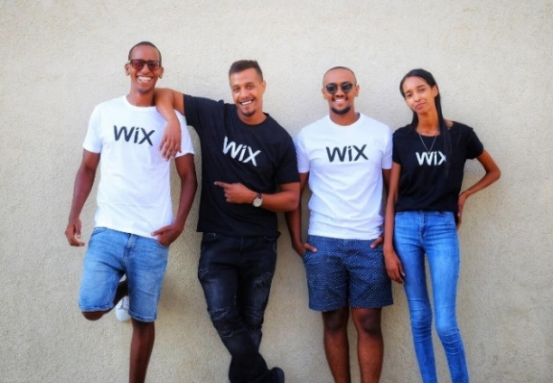 |  | THE TECH-CAREER MODEL  ◆ Technology Training: Cybersecurity, Network Engineering, Data Analysis, and QA Automation & AI, with international certifications and accreditation by Israeli government ministries.  ◆ Career Preparation: CV and LinkedIn workshops, interview coaching, company visits, professional mentoring, English tutoring, identity & belonging seminars.  ◆ Barrier Removal: Fully covered housing, 24/7 campus access, and holistic support services allowing students to fully immerse in their studies.  ◆ Career Placement: Personalized support that bridges training and career, matching each graduate with the right opportunity and standing behind them as they enter Israel's tech industry.  ◆ Community Leadership: As future leaders, students engage in social and volunteer activities in Lod. Many return after graduation to mentor and tutor, multiplying their impact.  ◆ InTech Exposure Programs: 450 participants exposed to high-tech over two years; 60% enrolled in STEM programs.  WHERE GRADUATES WORK  IBM, Wix, Intel, Check Point, Oracle, AT&T, Amazon, ironSource, Outbrain, Cognyte, and more.  BUILDING OUR FUTURE  As of July 2026, our permanent campus in Lod is 75% complete and set to open in early 2027 which will increase capacity to 300 students annually. It will feature modern classrooms, computer labs, on-campus dormitories for up to 54 students, and collaborative spaces. |  | ACCOMPLISHMENTS & RECOGNITION  ◆ Launch of Tech-Career Advance Hub, with the Ministry of Labor, integrating 1,100 Ethiopian Israelis into high-tech & STEM programs annually, June 2026  ◆ Northern Branch, launched February 2025  ◆ Named by JFNA as one of the best programs for Ethiopian Israelis, February 2024  ◆ Presidential Award for Volunteerism, June 2023  WHY IT MATTERS  Tech-Career graduates break glass ceilings, transform the socioeconomic status of entire families, and prove that diversity makes Israel’s tech industry stronger. Each graduate is a catalyst. Together, they are building a critical mass of Ethiopian Israeli professionals, a nucleus of leadership that is reshaping the image of an entire community in Israeli society.  PARTNER WITH US  We invite you to join us in transforming lives and strengthening Israel’s future. Whether by supporting our new campus, sponsoring student scholarships, or expanding programs, your investment will create lasting change for Ethiopian Israelis and Israel’s tech ecosystem. Together, we can ensure that talent, not background, determines success in Israeli high-tech. For more information, please contact:  Avigail Harel, Resource Development  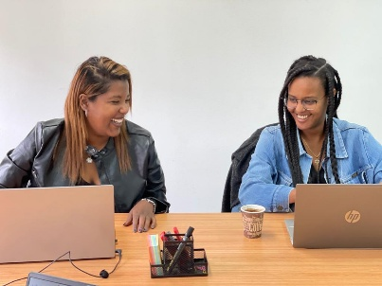  Avigail@tech-career.org | +972-52-376-9645

